Credit Card Fraud Detection Using Machine Learning

A Capstone Project

Submitted to the
Asian Institute of Management

Charity Fuentespina

CHAPTER 1

INTRODUCTION

1.1 Background of the Study
Credit card transactions have become an important part of modern financial activity, providing customers with convenient and efficient ways to make purchases and payments. However, the increasing volume of electronic transactions also creates opportunities for fraudulent activities. Credit card fraud can result in financial losses for customers and financial institutions, as well as additional costs associated with investigating suspicious transactions and resolving customer disputes. Because fraudulent transactions may occur in large volumes of legitimate transactions, identifying suspicious activity accurately and efficiently has become an important challenge for financial institutions.
Traditional fraud detection approaches often rely on predefined rules and manually identified patterns. While these approaches can be useful, they may have difficulty identifying changing or complex patterns of fraudulent behavior. Data science and machine learning provide an alternative approach by using historical transaction data to identify relationships and patterns that can be used to predict potentially fraudulent transactions. Statistical and data-mining techniques have therefore become important approaches in financial fraud detection research (Bolton & Hand, 2002; Ngai et al., 2011).
This capstone project applies a supervised machine learning approach to the detection of fraudulent credit card transactions. The dataset contains transaction and customer-related variables, including transaction amount, account balance, number of transactions, transaction hour, foreign transaction status, previous fraud information, merchant distance, and merchant risk score. The target variable, is_fraud, identifies whether a transaction is legitimate or fraudulent. A value of 0 represents a legitimate transaction, while a value of 1 represents a fraudulent transaction.
The project frames fraud detection as a binary classification problem. Several machine learning algorithms are developed and compared to determine which model can provide the most appropriate performance in distinguishing fraudulent transactions from legitimate ones. The models considered include Logistic Regression, Decision Tree, Random Forest, XGBoost, and Support Vector Machine. Their performance is evaluated using accuracy, precision, recall, F1-score, and ROC-AUC. These measures provide a broader assessment of model performance because fraud detection requires consideration of both missed fraudulent transactions and incorrectly flagged legitimate transactions.
The project also considers model interpretability and responsible use of machine learning. Feature importance and explainability techniques are used to better understand the factors contributing to model predictions, while a fairness assessment examines whether model performance differs across age groups. These additional analyses are important because a fraud detection model should not only provide acceptable predictive performance but should also be understandable and appropriately evaluated before being considered for practical use.

Problem Understanding and Framing

1.2.1 Business Problem

The business problem is appropriately framed as a fraud-detection and risk-management problem rather than as a purely technical prediction exercise. Financial fraud detection commonly uses statistical and data-mining approaches to identify unusual or suspicious patterns in transaction data (Bolton & Hand, 2002; Ngai et al., 2011). In this capstone, early identification of potentially fraudulent transactions is intended to reduce financial losses, protect customers, and improve the efficiency of fraud operations. The business framing is therefore consistent with the broader application of analytics to financial fraud detection.

Financial institutions face financial losses and reputational damage from fraudulent credit card transactions. The business problem framed in the notebook is therefore the detection of potentially fraudulent transactions early enough to reduce losses, protect customers, improve operational efficiency, and support financial-security requirements.

Data Science Task
The conversion of the business problem into a binary classification task is appropriate because the target variable has two outcomes: legitimate (0) and fraudulent (1). Supervised classification is suitable when historical observations contain known class labels that can be used to learn predictive relationships. In this study, the model will learn patterns from the transaction and customer-related variables to determine whether a transaction is likely to be fraudulent. The selected workflow uses established supervised-learning methods implemented through a standard machine-learning framework (Pedregosa et al., 2011).
The business problem is translated into a binary classification task. The target variable is is_fraud, where 0 represents a legitimate transaction and 1 represents a fraudulent transaction. The data science task is therefore to develop and compare classification models that can accurately distinguish between these two classes. The models will be evaluated using appropriate performance measures, including accuracy, precision, recall, F1-score, and ROC-AUC, to identify the model that provides the most suitable performance for detecting fraudulent transactions.
1.2.3 Success Metrics and Business KPIs
The selected technical metrics reflect the competing costs of missed fraud and false alarms. Recall is important because a false negative represents a fraudulent transaction that the model fails to identify, while precision measures how reliable the fraud alerts are. F1-score provides a balance between precision and recall, while ROC-AUC measures the model's ability to distinguish between legitimate and fraudulent transactions across different classification thresholds. Accuracy is also considered as a general measure of the model's overall correct predictions.
These technical metrics should ultimately be connected to business outcomes such as reduced fraud losses, fewer false fraud alerts, lower customer disputes, and improved investigation efficiency. Therefore, the success of the project will not be based solely on achieving high model accuracy but on selecting a model that can effectively support fraud detection and business decision-making. This approach is consistent with the use of statistical and data-mining methods to support financial fraud detection (Bolton & Hand, 2002).
Category | Metric/KPI | Purpose
Technical | Recall | Measures how many actual fraudulent transactions are detected; important for minimizing missed fraud.
Technical | Precision | Measures how many transactions flagged as fraud are actually fraudulent; limits false alarms.
Technical | F1-score | Balances precision and recall and is useful when both missed fraud and false positives matter.
Technical | ROC-AUC | Measures the model's ability to distinguish fraudulent from legitimate transactions across thresholds.
Business | Financial fraud losses | Should decrease as fraudulent transactions are prevented or detected.
Business | False-positive/customer dispute rate | Should decrease to protect customer experience and reduce unnecessary reviews.
Business | Fraud-operation costs | Should decrease through more effective automated detection and reduced manual investigation.

CHAPTER 2

DATA COLLECTION AND UNDERSTANDING

2.1 Dataset Overview
The analysis uses the provided credit.csv dataset containing 32,300 observations and 10 original variables. The dataset contains transaction- and customer-related variables such as transaction amount, account balance, transaction frequency, transaction hour, foreign transaction status, previous fraud information, merchant distance, and merchant risk score. The target variable, is_fraud, identifies whether a transaction is legitimate or fraudulent, with 0 representing a legitimate transaction and 1 representing a fraudulent transaction.
The original dataset contains nine predictor variables and one target variable. After feature engineering, one additional predictor, transaction_to_balance_ratio, was created, resulting in ten predictors and one target variable for the modeling dataset. The dataset contains 16,740 legitimate transactions (51.83%) and 15,560 fraudulent transactions (48.17%). This relatively balanced class distribution provides a useful starting point for model development and comparison because neither class overwhelmingly dominates the dataset.
However, this distribution should not be assumed to represent the actual prevalence of fraud in a real financial institution. Real-world fraud datasets may have substantially different class distributions and may contain changing patterns over time. Therefore, although the dataset is appropriate for developing and comparing classification models within this capstone, a production system would require further validation using real-world data with realistic fraud prevalence and preferably temporally separated observations.
Item | Finding
Original observations | 32,300
Original variables | 10
Target | is_fraud
Legitimate transactions | 16,740 (51.83%)
Fraudulent transactions | 15,560 (48.17%)
Initial missingness | Approximately 1.99%–2.24% depending on the variable; target had 0% missing
Initial data-type issue | age was stored as object and was converted to numeric
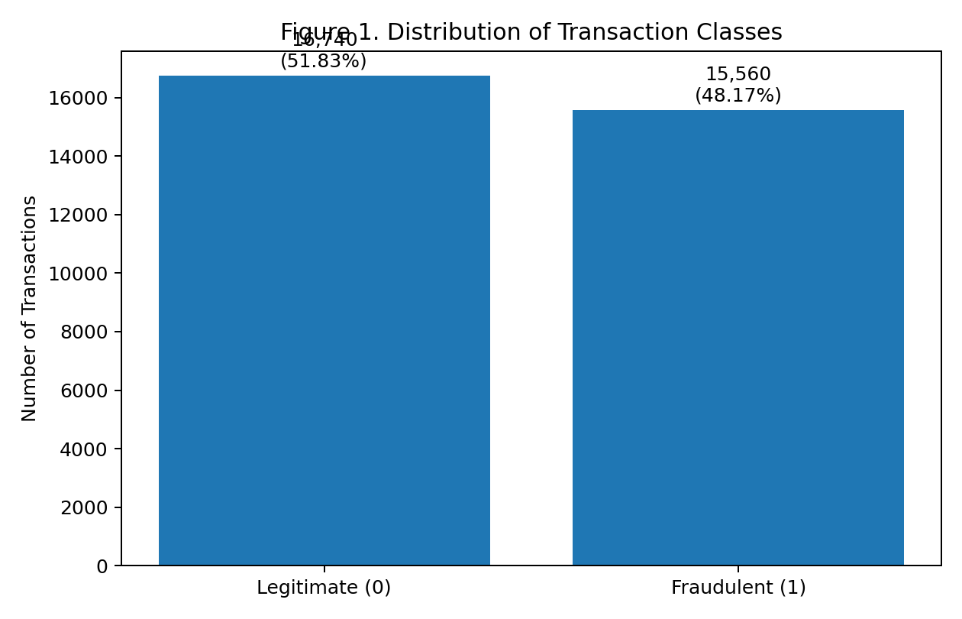Figure 1. Distribution of Legitimate and Fraudulent Transactions

2.2 Data Quality Findings

The data-quality assessment identified several issues that could distort model learning, including missing observations, invalid ages, an extreme negative account-balance placeholder, and transaction-hour values outside the valid range. Addressing these issues before model training is necessary because algorithms operate on the values supplied to them; invalid values can therefore become misleading predictive signals. The cleaning process demonstrates that data preparation is an integral part of the data-science task rather than a separate administrative activity.

- age was initially stored as an object and was converted to numeric.
- Missing values were present in all predictor variables but not in is_fraud.
- The largest initial missing-value percentage was for age at 2.24%.
- The dataset contained negative age values, which were treated as invalid and replaced with missing values.
- account_balance contained an extreme negative value (−99,999), treated as an invalid placeholder/outlier.
- transaction_hour contained values greater than 23; these were treated as invalid and replaced with missing values.
- The target was comparatively balanced, so severe class-imbalance techniques were not required for the analysis.

2.3 Data Dictionary

The data dictionary establishes the meaning, type, unit, and expected range of each variable. This is important because model performance depends on whether variables are represented consistently and interpreted correctly. For example, transaction hour must remain within the logical 0–23 range, while binary variables such as foreign-transaction status must be interpreted consistently. Establishing these definitions before modeling reduces ambiguity and supports reproducibility.

Variable | Type | Description / Unit | Observed/Expected Range
Age | float64 | Customer age / years | 18–74 after cleaning
transaction_amount | float64 | Transaction amount / USD | 1.07–14,999.71
account_balance | float64 | Current account balance / USD | 0.23–49,998.90 after cleaning
num_transactions_today | float64 | Number of transactions today / count | 1–49
is_foreign_transaction | float64 | Foreign transaction indicator / binary | 0 domestic, 1 foreign
transaction_hour | float64 | Hour of transaction / hour | 0–23 after cleaning
prev_fraud_flag | float64 | Previous fraud indicator / binary | 0 no previous fraud, 1 previous fraud
merchant_distance_km | float64 | Merchant distance from usual location / km | 0.1–4,999.8
merchant_risk_score | float64 | Merchant risk score | 1–15
is_fraud | int64 | Target: fraudulent vs. legitimate / binary | 0 legitimate, 1 fraudulent

2.4 Outlier and Distribution Analysis

The observed right-skewness and high-end outliers in transaction amount, account balance, transaction count, and merchant distance are potentially meaningful in a fraud-detection context. An unusual transaction may be exactly the type of observation that a fraud model needs to identify. Consequently, the project appropriately examined these values rather than automatically deleting them. At the same time, highly dispersed variables require careful preprocessing so that extreme values do not dominate algorithms that are sensitive to scale.

The notebook used box plots, histograms, and count plots to examine distributions. Transaction amount and account balance showed right-skewed behavior and high-end outliers. Transaction count and merchant distance also showed higher-end outliers. The transaction-hour distribution was relatively even across the day. Foreign transactions and previous-fraud flags were comparatively less frequent than their opposite categories.

In figure2, the histograms show that age is relatively uniform across 18–74, while transaction amount and account balance are right-skewed, with more observations at lower values and longer tails toward higher values. Merchant distance appears relatively uniform across its range, while merchant risk score is generally distributed across its range of 1–15, indicating varied levels of merchant risk. Overall, the distributions show sufficient variability across the numerical features for further analysis and modeling.

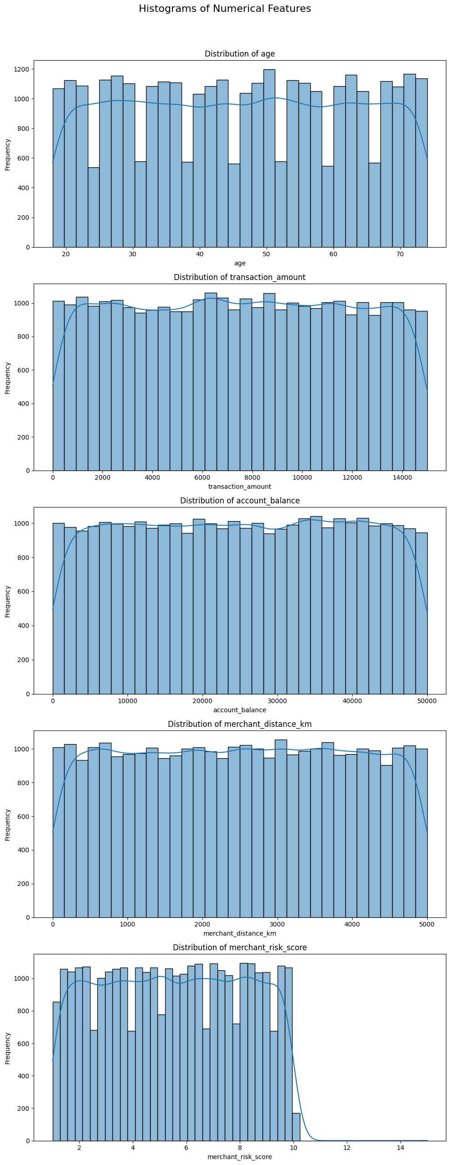
Figure 2. Distribution of Numerical Variables in the Credit Fraud Dataset

Figure 3 shows the count plots that foreign transactions are much fewer than domestic transactions, while previous fraud flags are also highly imbalanced, with most transactions having no previous fraud. Transaction hours are relatively evenly distributed, and number of transactions today varies across customers, with some missing values. The target variable, is_fraud, is relatively balanced between legitimate and fraudulent transactions, which is favorable for classification modeling but may not reflect the highly imbalanced fraud rates typically found in real-world datasets.

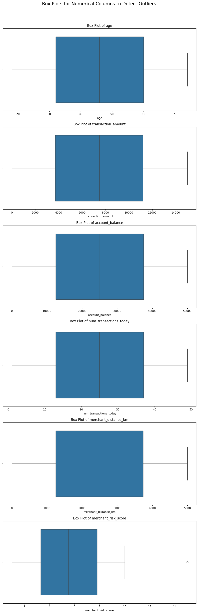Figure 3: Count Plots

In figure 4, the is_fraud variable shows a relatively balanced distribution, with 16,740 legitimate transactions (51.83%) and 15,560 fraudulent transactions (48.17%). This balance simplifies model training and evaluation compared with highly imbalanced real-world fraud datasets. However, it may not reflect actual fraud prevalence in financial institutions, which can affect model interpretation and deployment. Therefore, while accuracy can be considered, recall, precision, and F1-score remain important for evaluating fraud-detection performance.
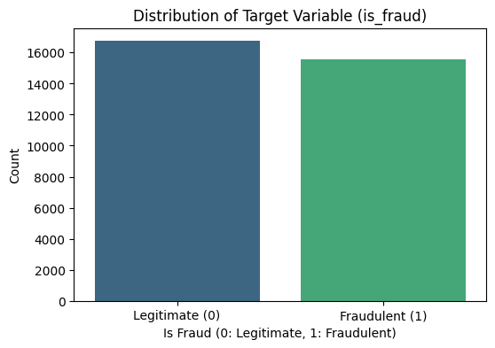
Figure 4: Distribution of Target Variable

CHAPTER 3

DATA PREPROCESSING, APPLIED EDA AND FEATURE ENGINEERING

3.1 Data Processing
Data preprocessing was conducted to transform the raw credit card transaction dataset into a clean and suitable format for exploratory analysis and machine learning. The process included identifying and removing duplicate records, addressing missing values, correcting invalid observations, converting variables into appropriate data types, and applying feature scaling where necessary.
A total of 298 duplicate records were identified and removed, leaving 32,002 observations. Missing values were handled using median imputation for continuous variables and mode imputation for discrete or pseudo-categorical variables. Invalid values, including negative ages, an extreme negative account balance, and transaction-hour values outside the valid 0–23 range, were also identified and addressed.
The notebook first performed exploratory data analysis during the data-understanding stage, including outlier detection, distribution analysis, count plots, and target-variable analysis. In the Step 3 preprocessing and feature-engineering workflow, duplicate rows were removed, missing values were imputed, selected numerical variables were standardized, the transaction_to_balance_ratio was created and standardized, and correlation analysis was then performed on the resulting variables.
After correlation analysis, Random Forest feature importance was used to assess the relative predictive contribution of the predictors. A 0.05 importance threshold was then applied; all ten predictors met the threshold and were retained in the feature-importance assessment. PCA was subsequently applied to the ten predictors to examine the dimensional structure. The modeling workflow then proceeded to the 80/20 stratified train-test split and supervised model comparison.

3.2 Duplicate Handling

Removing the 298 duplicate observations prevents repeated records from receiving disproportionate influence during model training. After removal, 32,002 observations remained. This is a straightforward but important data-integrity step because duplicate records can make the apparent amount of independent evidence larger than it actually is.

The dataset contained 298 duplicate rows. These duplicates were removed, leaving 32,002 observations for subsequent preprocessing and modeling.

3.3 Missing-Value Imputation
Median imputation for continuous variables and mode imputation for discrete or pseudo-categorical variables provides a simple and reproducible way to retain observations while eliminating missing inputs. After imputation, no missing values remained.
The notebook's preprocessing workflow, however, presents a potential preprocessing leakage limitation because imputation was performed before the final train-test split. Consequently, the imputation parameters were estimated using the complete analytical dataset rather than the training data alone. In a stricter modeling workflow, imputation parameters should be estimated only from the training set and then applied to validation and test observations. This can be implemented through a machine-learning Pipeline in scikit-learn.
Feature Group | Method | Values Used
Continuous numerical variables | Median | age = 46.0; transaction_amount = 7,468.145; account_balance = 25,056.3; merchant_distance_km = 2,508.8; merchant_risk_score = 5.5
Discrete/pseudo-categorical variables | Mode | num_transactions_today = 16.0; transaction_hour = 4.0; is_foreign_transaction = 0.0; prev_fraud_flag = 0.0

After imputation, all predictor variables and the target contained zero missing values.

3.4 Feature Scaling
Standardization places numerical variables on comparable scales, which is particularly relevant for algorithms such as Logistic Regression and Support Vector Machines. Scaling also improves the numerical consistency of optimization procedures.
StandardScaler was applied to age, transaction_amount, account_balance, num_transactions_today, merchant_distance_km, and merchant_risk_score. The resulting standardized variables had approximately zero mean and unit standard deviation.
A preprocessing leakage limitation should be noted because both imputation and scaling were performed before the final train-test split. The imputation values were estimated from the full analytical dataset, and StandardScaler was also fitted before the split. A stricter implementation would fit all preprocessing transformations only on the training data and subsequently apply the learned transformations to the test data through a preprocessing Pipeline.

3.5 Domain-Derived Feature

The transaction-to-balance ratio was created after the notebook standardized transaction_amount and account_balance. It was calculated as the standardized transaction_amount divided by the standardized account_balance, with a small epsilon of 1e-6 added to the denominator to avoid division by zero. The ratio was then standardized as a separate feature. Before this second standardization, the engineered ratio had a highly dispersed distribution, with a maximum of 22,796.96. Because the feature is therefore based on already standardized component variables rather than the original monetary units, its interpretation should be treated cautiously. A future implementation should create domain-derived ratios before feature scaling if the intended meaning is the transaction amount relative to the original account balance. The notebook created transaction_to_balance_ratio after standardizing transaction_amount and account_balance. The calculation used transaction_amount divided by account_balance plus an epsilon of 1e-6, followed by StandardScaler on the new ratio. Before the ratio itself was standardized, its maximum was 22,796.96, so the engineered feature was highly dispersed and should be interpreted cautiously.

3.6 Correlation Analysis

The strongest simple correlations with fraud were observed for merchant distance, transaction amount, and merchant risk score. These findings are consistent with the later Random Forest importance results, which also ranked these variables highly. However, correlation should not be interpreted as causation, and relatively weak pairwise correlations do not imply that a variable has no predictive value. Machine-learning models can use nonlinear or conditional relationships that are not captured by a simple correlation coefficient.

Variable | Correlation with is_fraud
merchant_distance_km | 0.257261
transaction_amount | 0.205602
merchant_risk_score | 0.216626
num_transactions_today | 0.121236
Age | -0.097120
transaction_to_balance_ratio | 0.021976
account_balance | -0.004836

The strongest simple correlations with the target were merchant_distance_km, transaction_amount, and merchant_risk_score. The pairwise correlations among most predictor variables were close to zero, suggesting limited linear multicollinearity in the inspected variables.
In figure 5, the correlation matrix shows the strength and direction of the linear relationships among the numerical variables and the fraud indicator. Overall, the predictors exhibit relatively weak to moderate correlations with is_fraud, indicating that no single variable has a very strong linear relationship with fraud. Merchant distance has the strongest positive correlation with fraud (r = 0.257), followed by merchant risk score (r = 0.217) and transaction amount (r = 0.206). Number of transactions also shows a weak positive relationship (r = 0.121), while age has a weak negative correlation with fraud (r = −0.097). The transaction-to-balance ratio (r = 0.022) and account balance (r = −0.005) have almost no linear relationship with the fraud indicator. These results suggest that fraud is influenced by a combination of transaction characteristics rather than a single predictor. However, correlation measures linear association only and should not be interpreted as evidence of causation or as a complete measure of predictive importance.

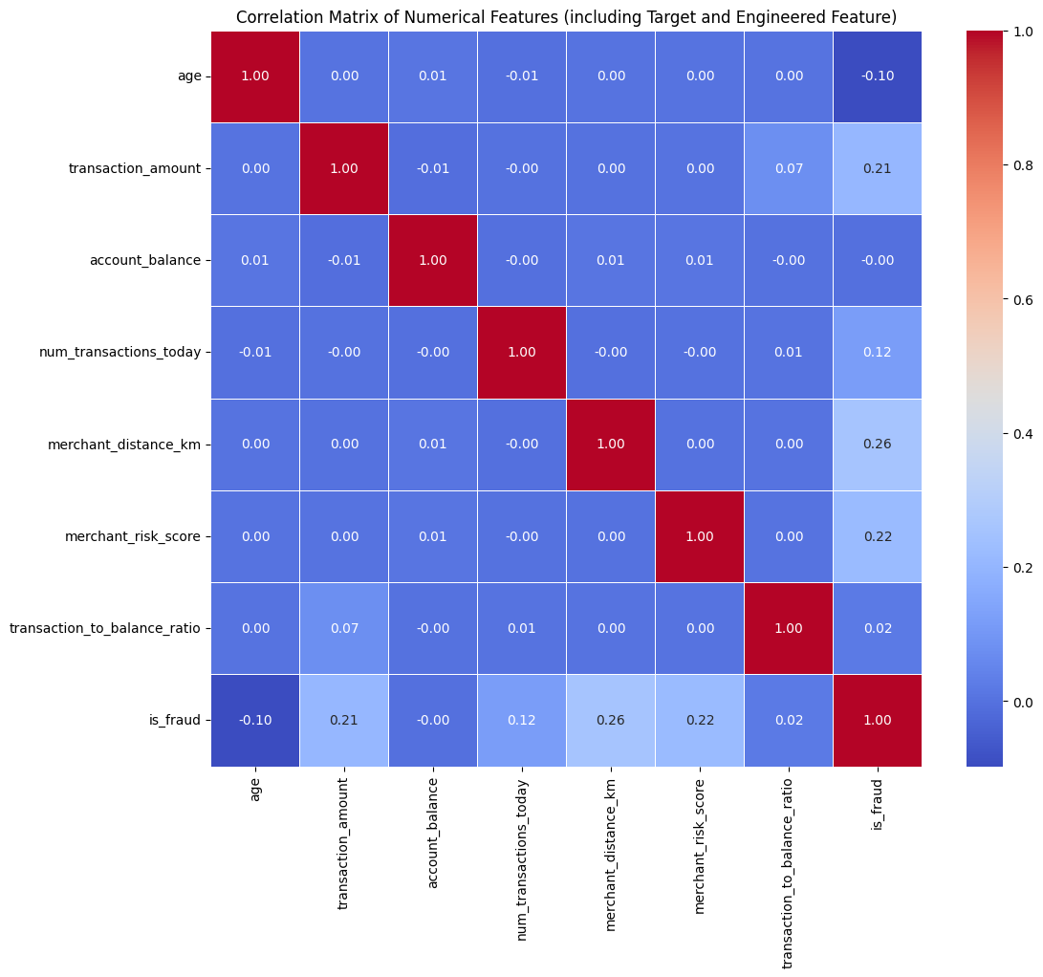Figure 5: Correlation Matrix

3.7 Random Forest Feature Importance

Random Forest identified merchant distance, transaction amount, and merchant risk score as the three most important predictors. Random Forest is well suited to exploratory feature assessment because it combines multiple decision trees and can provide measures of variable importance (Breiman, 2001). The fact that all ten predictors exceeded the notebook's retention threshold means that no variable was removed solely on the basis of the selected importance rule. These results identify predictive contribution, not causal influence.
Rank | Feature | Importance
1 | merchant_distance_km | 0.166855
2 | transaction_amount | 0.138635
3 | merchant_risk_score | 0.128916
4 | transaction_to_balance_ratio | 0.096304
5 | account_balance | 0.093292
6 | num_transactions_today | 0.090489
7 | Age | 0.088783
8 | transaction_hour | 0.072230
9 | prev_fraud_flag | 0.067561
10 | is_foreign_transaction | 0.056935

All ten predictors met the notebook's importance threshold of 0.05, so all were retained.

3.8 Principal Component Analysis (PCA)

PCA demonstrated that a large proportion of the variance could be represented by a relatively small number of components. However, the modeling workflow retained the original features rather than replacing them with principal components. This is a defensible decision for a business-oriented fraud project because original variables such as transaction amount and merchant distance are easier for fraud investigators and managers to interpret than abstract principal components.

The figure below shows the relative contribution of each predictor to the Random Forest model. Merchant distance, transaction amount, and merchant risk score are the three most important features, suggesting that these variables provide the strongest predictive information for distinguishing fraudulent from legitimate transactions. The results also show that all selected variables contribute to the model, although their relative importance varies.
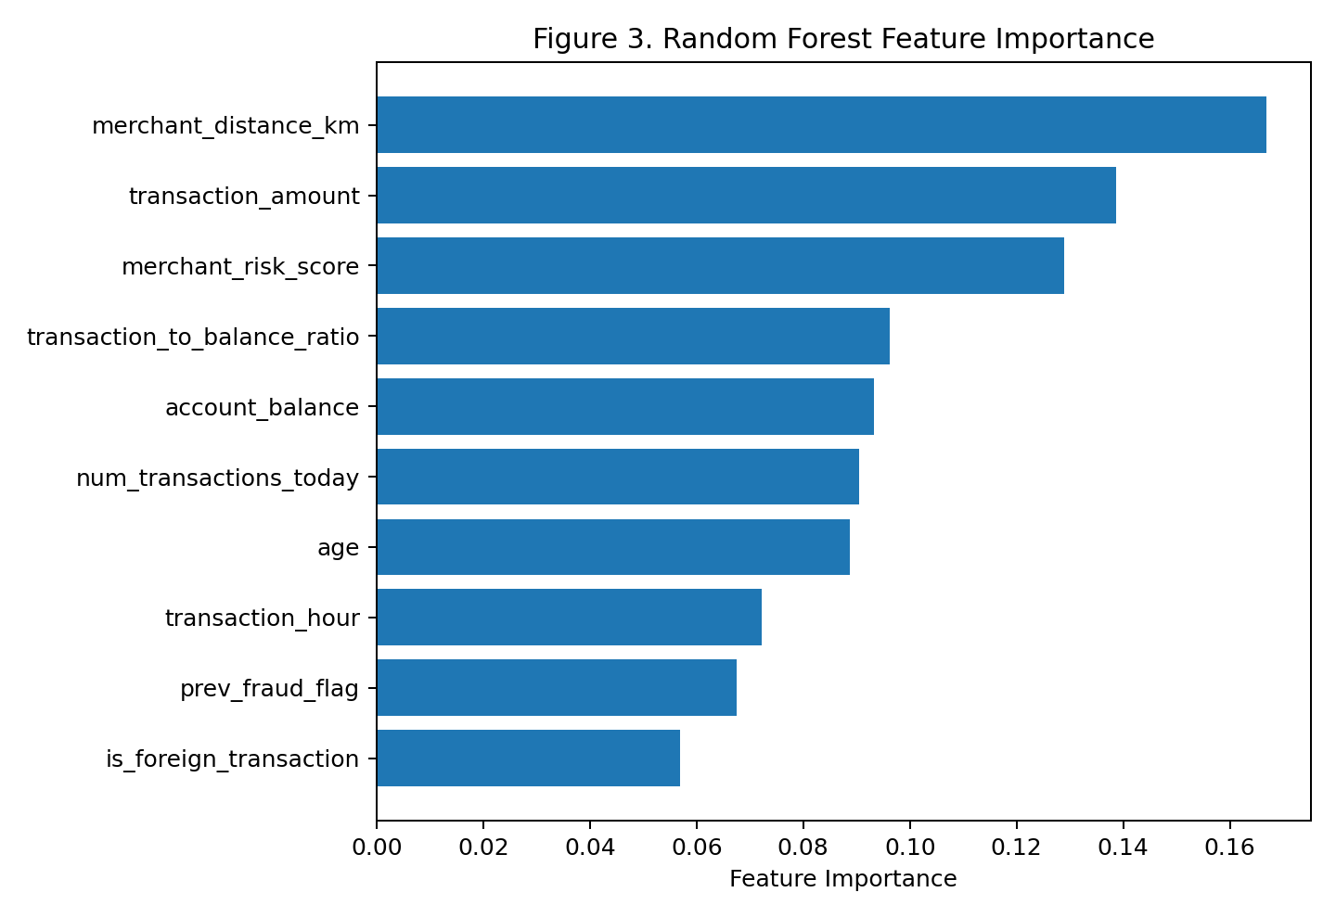
Figure 6. Random Forest Feature Importance
In Figure 7, PCA showed that the first principal component explained 86.97% of the variance. The first two components explained 88.92%, the first three 90.76%, and the first five 94.38%. The first eight components explained 99.65% of the variance. This indicates substantial concentration of variance in a small number of components, although the modeling workflow retained the original features rather than replacing them with PCA components.

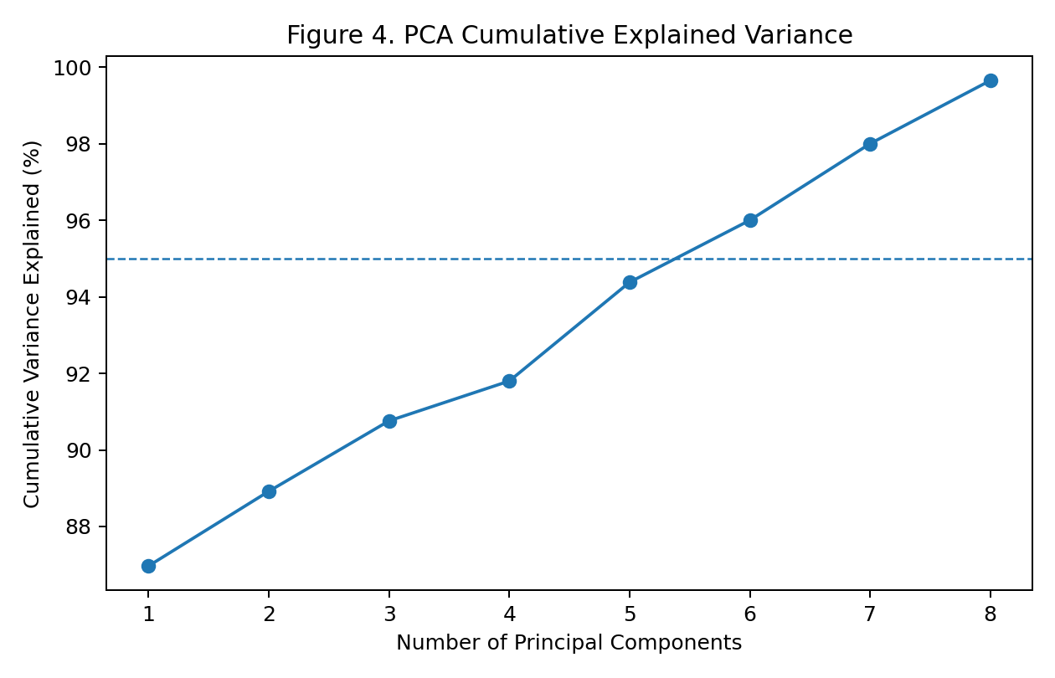
Figure 7. PCA Cumulative Explained Variance.

CHAPTER 4
MODEL IMPLEMENTATION

4.1 Introduction

This chapter presents the implementation and evaluation of the classification models used for credit card fraud detection. The dataset was divided into training and testing sets, followed by the development of five baseline models: Logistic Regression, Decision Tree, Random Forest, XGBoost, and Support Vector Machine. Their performance was compared using accuracy, precision, recall, F1-score, and ROC-AUC. Hyperparameter tuning was then applied to Logistic Regression and XGBoost to improve performance and identify the most suitable model for the fraud-detection task.

4.2 Train-Test Split

After preprocessing, scaling, feature engineering, correlation analysis, Random Forest feature-importance assessment, and PCA, the notebook performed an 80/20 stratified train-test split with random_state=42. The resulting 25,601 training observations and 6,401 test observations provide the basis for baseline model training and final test evaluation. The split was performed after preprocessing transformations had already been fitted on the full analytical dataset, which creates the preprocessing-leakage limitation discussed later. For future deployment-oriented work, temporal validation would provide an even stronger assessment because fraud patterns can change over time.

The data was divided into 80% training and 20% testing sets using stratification and random_state=42. The training set contained 25,601 observations and the test set contained 6,401 observations.

4.3 Baseline Model Comparison

The baseline comparison demonstrates that different algorithms optimize different aspects of performance. Logistic Regression produced the highest F1-score and ROC-AUC, SVM produced the highest accuracy and precision, and XGBoost produced the highest baseline recall. Decision Tree performed substantially worse. The comparison supports the use of multiple candidate algorithms rather than assuming that the most complex method will automatically be the best. The selected algorithms represent established approaches for supervised classification, including Random Forest (Breiman, 2001), SVM (Cortes & Vapnik, 1995), and XGBoost (Chen & Guestrin, 2016).

Figure 8 compares the five baseline models using accuracy, precision, recall, F1-score, and ROC-AUC. Logistic Regression achieved the strongest F1-score and ROC-AUC, SVM had the highest accuracy and precision, while XGBoost achieved the highest recall. These results guided the selection of Logistic Regression and XGBoost for hyperparameter tuning.

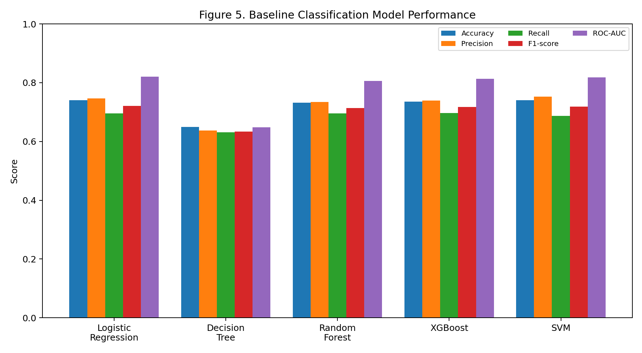Figure 8. Baseline Classification Model Performance.

Model | Accuracy | Precision | Recall | F1-score | ROC-AUC
Logistic Regression | 74.00% | 74.71% | 69.58% | 72.05% | 82.07%
SVM | 74.10% | 75.31% | 68.76% | 71.89% | 81.83%
XGBoost | 73.54% | 73.87% | 69.70% | 71.73% | 81.30%
Random Forest | 73.18% | 73.39% | 69.51% | 71.40% | 80.58%
Decision Tree | 64.93% | 63.72% | 63.12% | 63.42% | 64.86%

Logistic Regression was the leading baseline model because it produced the highest F1-score and ROC-AUC. SVM produced the highest accuracy and precision, while XGBoost produced the highest baseline recall. Decision Tree performed substantially worse on ROC-AUC and the other metrics.

4.4 Hyperparameter Tuning

Hyperparameter tuning was used to determine whether model configurations could improve predictive performance. The best cross-validation F1-score was 0.7352 for Logistic Regression and 0.7275 for XGBoost. The use of cross-validation provides a more stable basis for comparing configurations than relying on a single training result. Importantly, tuning should be conducted without using the final test set for model selection, because doing so would weaken the independence of the final evaluation.

Model | Best Parameters | CV F1-score
Logistic Regression | solver=liblinear; max_iter=1000; class_weight=balanced; C=0.01 | 0.7352
XGBoost | subsample=0.7; n_estimators=200; min_child_weight=5; max_depth=4; learning_rate=0.05; colsample_bytree=1.0 | 0.7275

4.5 Tuned Model Results

Tuning improved Logistic Regression's F1-score from 72.05% to 72.96% and recall from 69.58% to 72.69%. Although Tuned XGBoost had slightly higher precision, Tuned Logistic Regression produced stronger recall and F1-score. XGBoost is a powerful tree-boosting approach designed for scalable predictive modeling (Chen & Guestrin, 2016), but the results of this particular dataset show that greater model complexity did not translate into the best overall balance of fraud-detection performance.

Figure 9 compares the tuned Logistic Regression and XGBoost models. Tuned Logistic Regression achieved slightly higher accuracy, recall, F1-score, and ROC-AUC, while XGBoost had higher precision. Overall, Logistic Regression provided the better balance of performance and was selected as the final model.

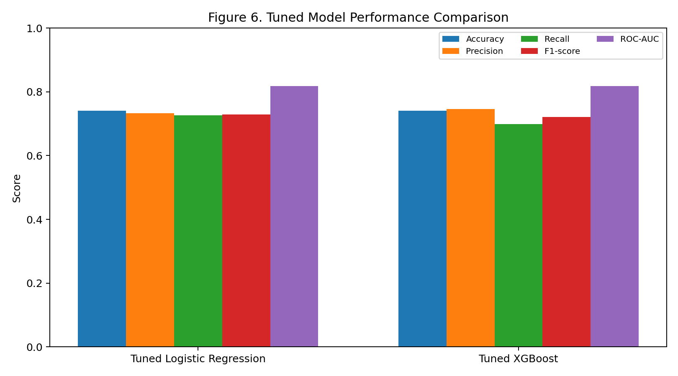
Figure 9. Tuned Model Performance Comparison.

Model | Accuracy | Precision | Recall | F1-score | ROC-AUC
Tuned Logistic Regression | 74.05% | 73.24% | 72.69% | 72.96% | 81.83%
Tuned XGBoost | 74.02% | 74.58% | 69.87% | 72.15% | 81.75%

Tuning improved Logistic Regression's F1-score from 72.05% to 72.96%, while recall increased from 69.58% to 72.69%. The tuned model therefore provided a better balance between detecting fraud and limiting false positive classifications.

4.6 Final Model Selection

Tuned Logistic Regression was selected because it provided the strongest balance of recall and F1-score among the tuned models while maintaining competitive accuracy, precision, and ROC-AUC. Its relative interpretability is also valuable in a financial setting where users may need to understand and review model-supported decisions. The selection therefore considers both predictive performance and practical usability rather than relying on accuracy alone.

Figure 10 presents the performance of the final tuned Logistic Regression model. The model achieved 74.05% accuracy, 73.24% precision, 72.69% recall, 72.96% F1-score, and 81.83% ROC-AUC. These results support its selection as the final model because it provided a strong balance between fraud detection performance and interpretability.
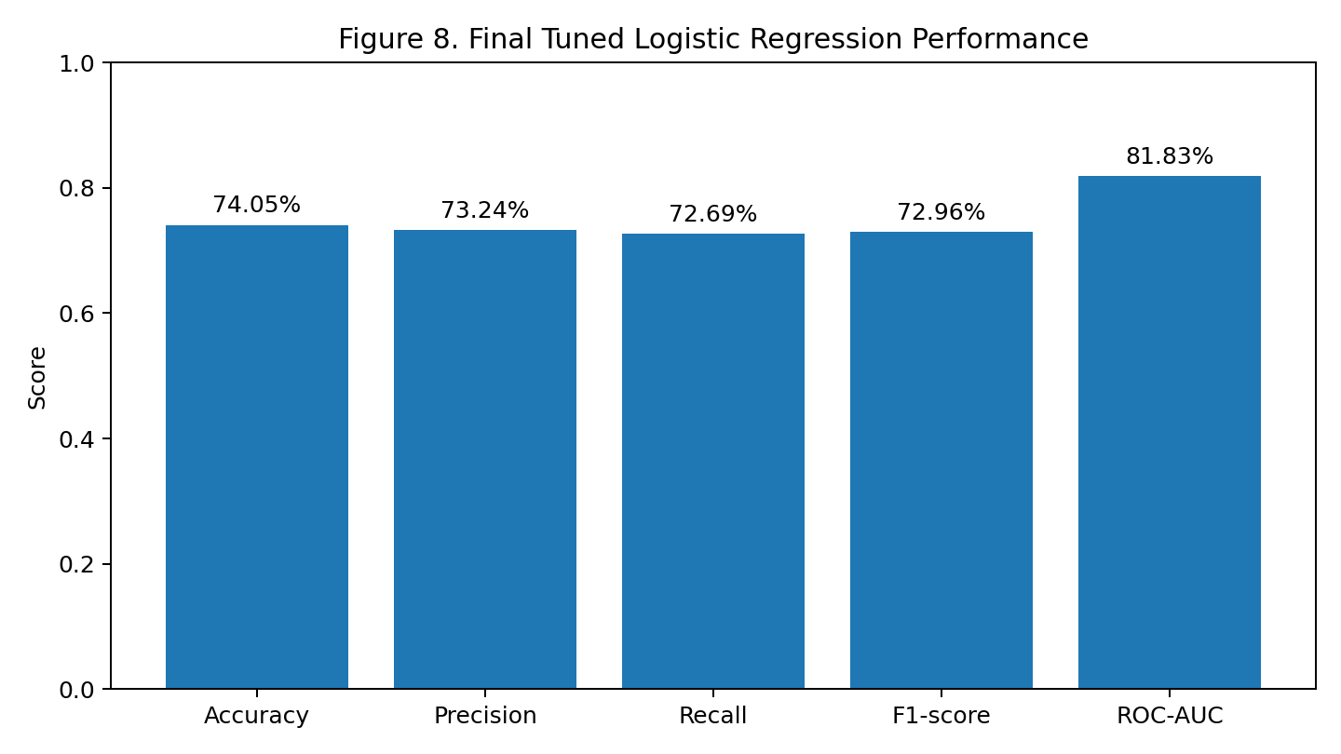Figure 10. Final Tuned Logistic Regression Performance.

CHAPTER 5

CRITICAL THINKING, ETHICAL AI AND BIAS AUDITING

5.1 Introduction

This chapter evaluates the model beyond predictive performance by examining its explainability, fairness, and limitations. SHAP, LIME, Partial Dependence Plots, and Individual Conditional Expectation are used to understand model behavior, while an age-group analysis assesses differences in performance across age quartiles. The chapter also discusses ethical considerations, model limitations, and recommendations for responsible use and future improvement.

5.2 Model Explainability

The use of SHAP, LIME, Partial Dependence Plots, and ICE extends the evaluation beyond predictive performance. SHAP provides a unified framework for assigning feature contributions to predictions (Lundberg & Lee, 2017), while LIME explains individual predictions through a locally interpretable approximation (Ribeiro et al., 2016). These methods can help analysts understand why transactions receive particular risk scores. However, explanations describe model behavior and should not automatically be interpreted as causal evidence.

The notebook applied four complementary explainability techniques: SHAP, LIME, Partial Dependence Plots, and Individual Conditional Expectation. SHAP was used for global and local feature contributions; LIME was used to explain individual transaction predictions; PDP examined average relationships between selected features and predicted fraud probability; and ICE examined how those relationships vary across individual transactions.

Figure 11 illustrates how the different features contributed to the model's fraud predictions. Features with positive SHAP values increase the model's tendency to classify a transaction as fraudulent, while negative SHAP values push the prediction toward a legitimate transaction. The magnitude of the SHAP value indicates the strength of a feature's contribution to the prediction. Overall, the figure helps identify which variables have greater influence on the model's decisions and provides an interpretable view of model behavior. However, these contributions represent associations within the model and should not be interpreted as causal effects.
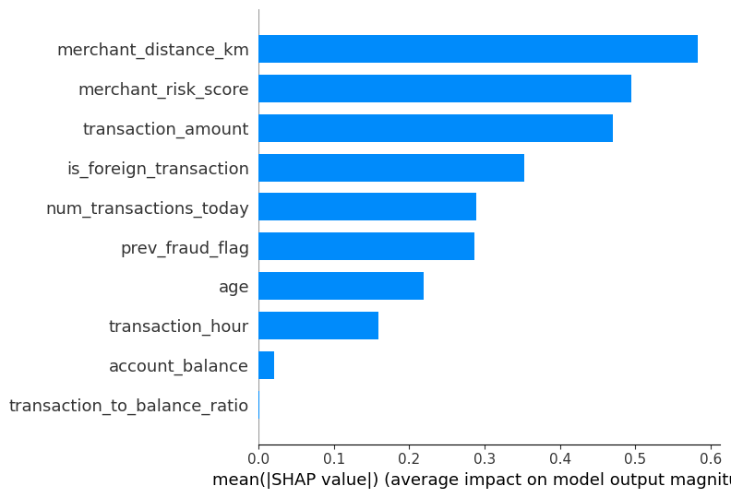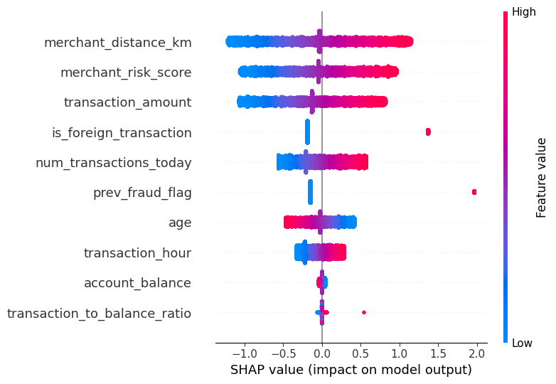
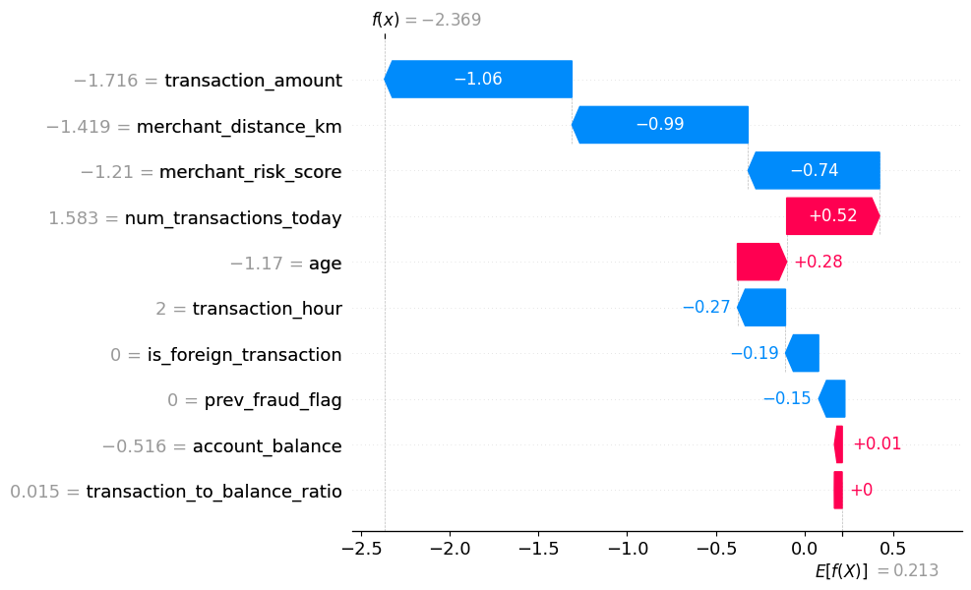
Figure 11: SHAP

In figure 12, the LIME explains the model's prediction for an individual transaction by showing the features that contributed most strongly to the prediction. Features pushing the prediction toward fraud indicate factors that increased the model's estimated fraud probability, while features pushing it toward a legitimate classification reduced that probability. The size of each contribution reflects its relative influence on the specific prediction. Thus, the figure provides a local explanation of why the model classified the selected transaction as fraudulent or legitimate. These contributions describe model behavior and should not be interpreted as evidence of causation.
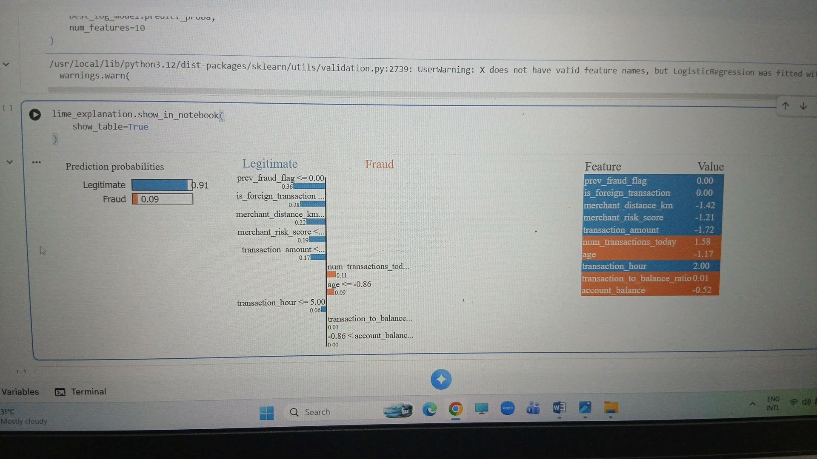

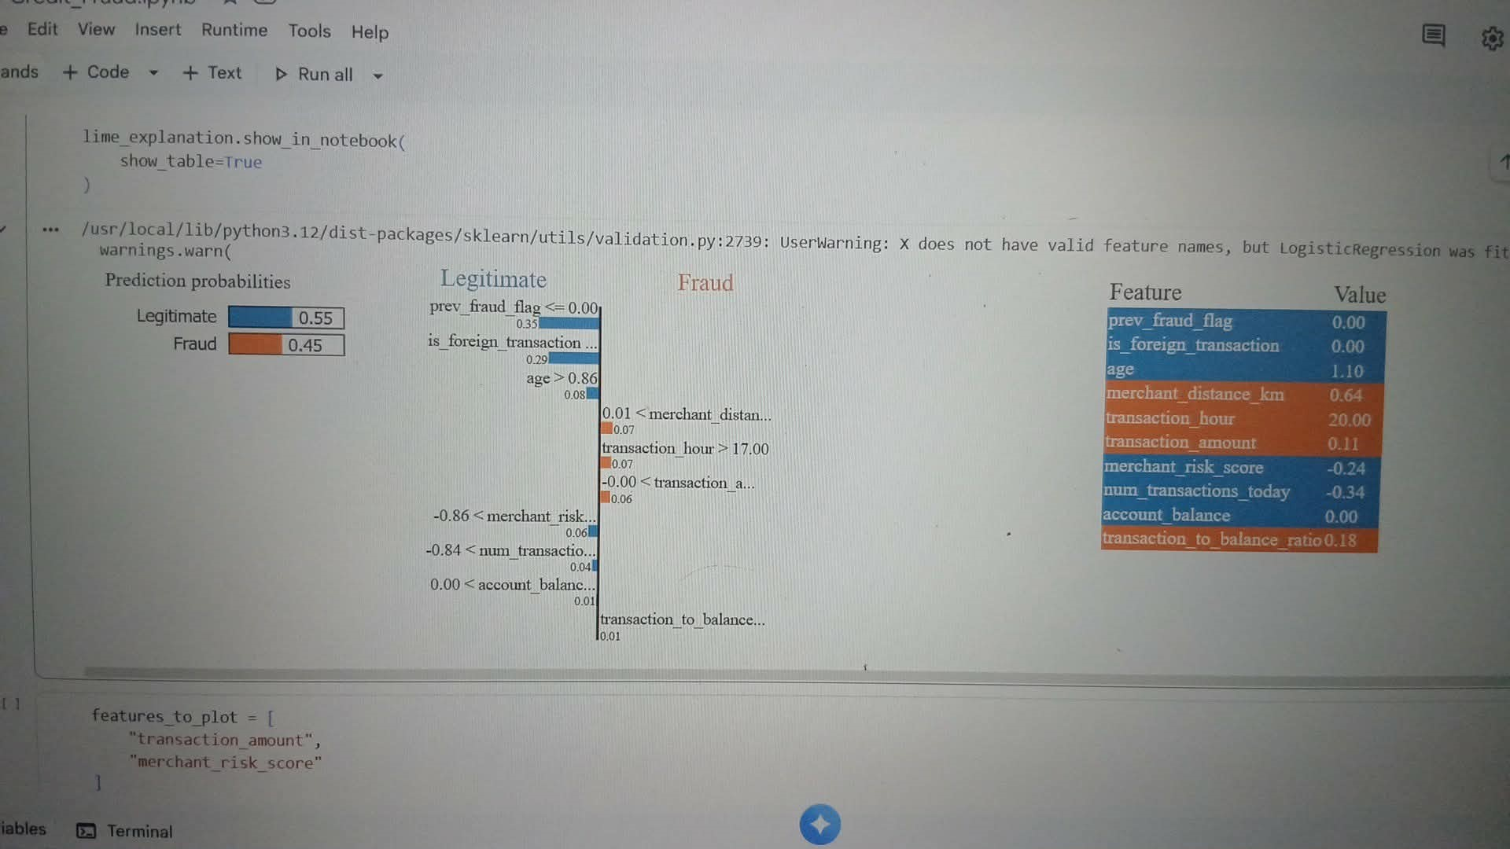Figure 12: LIME

Figure 13 shows the Partial Dependence Plots (PDPs) which illustrates how changes in individual features are associated with the model's predicted probability of fraud, while averaging over the effects of the other variables. An upward trend indicates that higher values of the feature generally increase the predicted likelihood of fraud, while a downward trend indicates a lower predicted likelihood. Relatively flat sections suggest limited influence within that range. Overall, the PDPs help illustrate how the model responds to changes in key predictors and provide an interpretable view of the model's behavior. These relationships describe the model's predictions and should not be interpreted as causal effects.
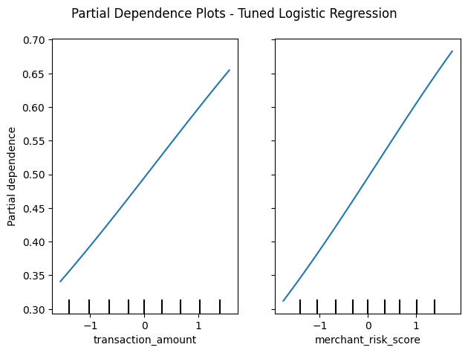
Figure 13. Partial Dependence Plots

The ICE plot shows how changes in selected features affect the model’s predicted probability of fraud for individual transactions. Each line represents an individual observation, allowing differences in model responses across transactions to be observed. The figure provides a more detailed view of individual-level model behavior and complements the overall patterns shown by the PDP analysis. These relationships describe model predictions and should not be interpreted as causal effects.

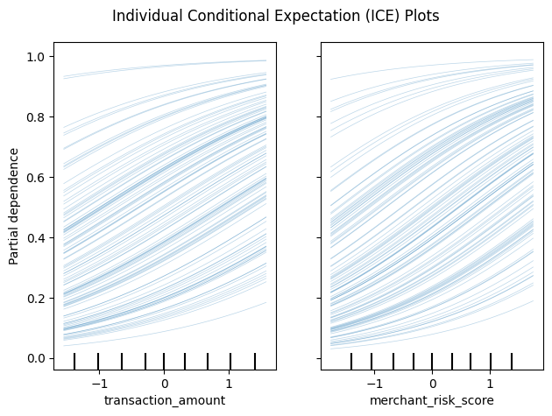 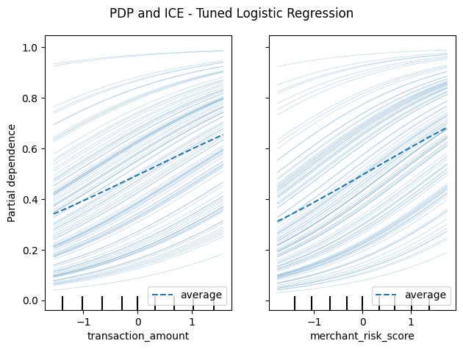 Figure 14: ICE
These methods improve transparency but should be interpreted as explanations of model behavior rather than proof of causal relationships. A feature that strongly influences a prediction does not necessarily cause fraud.

5.3 Age-Group Fairness Audit

The age-group audit found a recall difference of approximately 10.35 percentage points between the youngest and oldest quartiles. This result does not, by itself, prove discriminatory behavior; differences may arise from underlying transaction patterns or data characteristics. Nevertheless, the disparity is large enough to justify continued monitoring. Responsible AI guidance emphasizes that organizations should identify, measure, and manage risks throughout the AI lifecycle (Tabassi, 2023). In a production fraud system, fairness monitoring should therefore be treated as an ongoing governance activity rather than a one-time test.
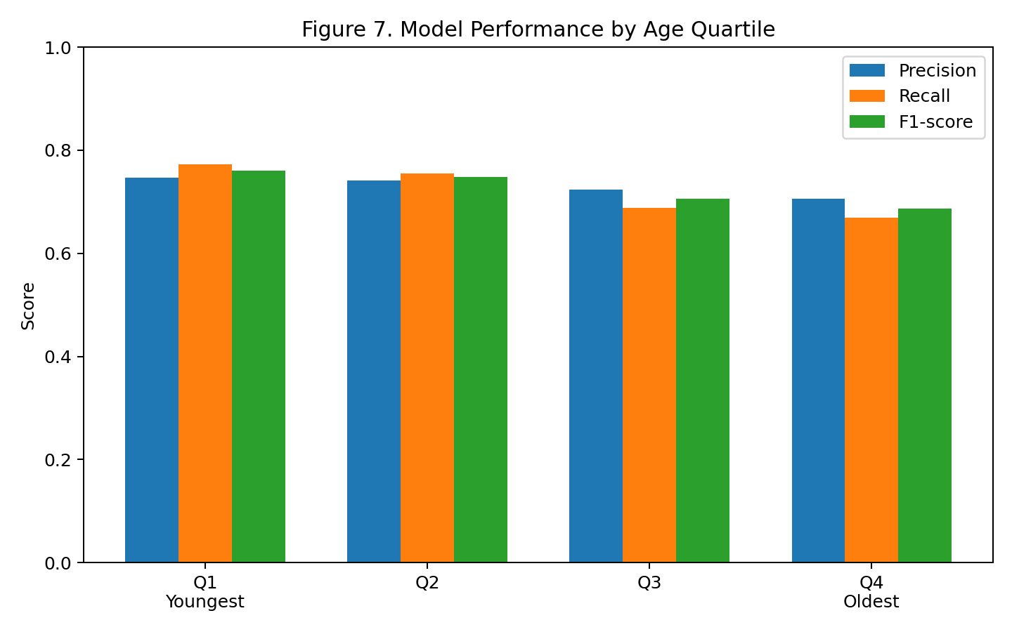
Figure 15. Model Performance by Age Quartile

Age Group | N | Precision | Recall | F1-score
Q1 Youngest | 1,644 | 74.73% | 77.32% | 76.00%
Q2 | 1,667 | 74.20% | 75.45% | 74.82%
Q3 | 1,495 | 72.36% | 68.82% | 70.54%
Q4 Oldest | 1,595 | 70.63% | 66.97% | 68.75%

The youngest quartile had the highest recall and F1-score, while the oldest quartile had the lowest. The recall difference between Q1 and Q4 was approximately 10.35 percentage points. This indicates a performance disparity that warrants monitoring, but it should not automatically be interpreted as evidence of algorithmic discrimination because group differences may also arise from differences in the underlying data.
The notebook did not assess gender, race, or socioeconomic status because those attributes were not available in the dataset.

5.4 Model Limitations

The main limitations concern generalizability, preprocessing leakage risk, the relatively balanced class prevalence compared with many real-world fraud settings, the highly dispersed transaction-to-balance ratio, and the need for additional fairness and temporal validation. These limitations do not invalidate the capstone findings; rather, they define the conditions under which the results should be interpreted. A responsible deployment decision should require additional validation before the model is used for high-impact financial decisions.
- The dataset is relatively balanced between fraud and legitimate transactions, which may not reflect the highly imbalanced fraud prevalence commonly encountered in operational financial systems.
- The notebook has a preprocessing-leakage limitation because imputation and scaling were performed before the final train-test split. A stricter implementation would fit these preprocessing transformations only on the training data, preferably through a machine-learning Pipeline.
- Generalizability is limited because the dataset contains 32,300 observations and 10 original variables and may not represent other institutions, customer populations, merchants, or time periods.
- Predictive performance does not establish causal relationships between transaction characteristics and fraud.
- The fairness audit was limited to age groups because other potentially relevant demographic attributes were not available.

5.5 Integrated Discussion

The capstone demonstrates a complete supervised-learning workflow for credit card fraud detection. The analysis begins with a clearly defined business problem and translates it into a binary classification task. The dataset inspection then identifies important quality issues, including missing data, duplicate records, and invalid values. These issues were addressed before modeling, producing a complete analytical dataset.
The exploratory analysis suggests that transaction characteristics such as merchant distance, transaction amount, and merchant risk score contain useful predictive information. Random Forest feature importance similarly placed these variables among the most influential predictors. All ten predictors met the notebook's 0.05 importance threshold. The engineered transaction-to-balance ratio also showed a highly dispersed distribution before it was standardized as a feature; because it was created after transaction_amount and account_balance had already been standardized, its domain interpretation should be treated cautiously.
Model comparison shows that no single complex algorithm dramatically outperformed all alternatives. Logistic Regression performed particularly well despite its relative simplicity. After hyperparameter tuning, it achieved the best F1-score among the evaluated models and improved recall substantially. This supports selecting the tuned Logistic Regression model as a practical baseline for further development, especially where interpretability is important.

The explainability and fairness analyses strengthen the capstone beyond predictive performance alone. SHAP, LIME, PDP, and ICE provide multiple perspectives on model behavior, while the age-group audit demonstrates why model performance should be monitored across groups rather than relying only on overall accuracy or F1-score.

5.6 Recommendations

Future improvements should use a Pipeline to prevent preprocessing leakage, validate the model using realistic fraud rates and time-based data, and optimize the classification threshold based on fraud and false-positive costs. Model and financial KPIs should be monitored after deployment, with regular fairness audits across relevant groups. The transaction-to-balance ratio should also be examined using robust transformations or caps. Finally, calibrated and cost-sensitive models should be compared, while explainability tools and human review should support high-impact fraud decisions.

5.7 Conclusion
This capstone follows the analytical workflow implemented in the provided Credit_Fraud(1).ipynb notebook, from problem framing and data understanding through the notebook's initial exploratory analysis, Step 3 preprocessing and feature engineering, correlation analysis, Random Forest feature-importance assessment, PCA, train-test splitting, model comparison, hyperparameter tuning, explainability, and age-group performance disparity analysis.
The original dataset contained 32,300 observations and 10 variables, consisting of nine predictors and one binary target variable. After data cleaning, duplicate removal, missing-value imputation, and feature engineering, the analysis proceeded to exploratory analysis, Random Forest feature-importance assessment, PCA, and supervised classification.
Five baseline classification algorithms were compared: Logistic Regression, Decision Tree, Random Forest, XGBoost, and Support Vector Machine. Logistic Regression produced the strongest baseline F1-score and ROC-AUC, while SVM achieved the highest baseline accuracy and precision and XGBoost achieved the highest baseline recall.
Hyperparameter tuning was subsequently applied to Logistic Regression and XGBoost. Among the tuned models evaluated, Tuned Logistic Regression provided the strongest balance of recall and F1-score. On the test set, it achieved 74.05% accuracy, 73.24% precision, 72.69% recall, 72.96% F1-score, and 81.83% ROC-AUC.
The explainability analysis using SHAP, LIME, Partial Dependence Plots, and Individual Conditional Expectation provided additional insight into model behavior. The age-group performance disparity assessment also identified a 10.35-percentage-point difference in recall between the youngest and oldest age quartiles. This finding warrants monitoring but does not, by itself, establish discriminatory behavior.
The analysis also identified important limitations. In particular, missing-value imputation and scaling were performed before the final train-test split, creating a preprocessing leakage limitation. The dataset's relatively balanced fraud prevalence may also differ substantially from real-world financial environments. In addition, the transaction_to_balance_ratio was created after scaling transaction_amount and account_balance and showed a highly dispersed pre-feature-scaling distribution, so its interpretation requires caution. Finally, the age-group assessment did not constitute a comprehensive fairness evaluation.
The most important conclusion is that a successful fraud-detection solution should not be evaluated solely by predictive accuracy. Financial impact, false-positive burden, interpretability, data quality, preprocessing integrity, generalizability, and group-level performance must also be considered. The capstone therefore provides a useful analytical foundation for further development while clearly identifying the technical and governance safeguards required before real-world implementation.

Appendix A. Model Performance Summary

Model | Accuracy | Precision | Recall | F1 | ROC-AUC
Logistic Regression | 0.740041 | 0.747126 | 0.695751 | 0.720524 | 0.820679
Decision Tree | 0.649274 | 0.637197 | 0.631203 | 0.634186 | 0.648634
Random Forest | 0.731761 | 0.733904 | 0.695102 | 0.713976 | 0.805803
XGBoost | 0.735354 | 0.738742 | 0.697048 | 0.717290 | 0.812999
SVM | 0.740978 | 0.753108 | 0.687642 | 0.718888 | 0.818330
Tuned Logistic Regression | 0.740509 | 0.732353 | 0.726889 | 0.729611 | 0.818345
Tuned XGBoost | 0.740197 | 0.745845 | 0.698670 | 0.721487 | 0.817466

Appendix B: References

Breiman, L. (2001). Random forests. Machine Learning, 45(1), 5–32. https://doi.org/10.1023/A:1010933404324

Bolton, R. J., & Hand, D. J. (2002). Statistical fraud detection: A review. Statistical Science, 17(3), 235–255. https://doi.org/10.1214/ss/1042727940

Chen, T., & Guestrin, C. (2016). XGBoost: A scalable tree boosting system. In Proceedings of the 22nd ACM SIGKDD International Conference on Knowledge Discovery and Data Mining (pp. 785–794). ACM. https://doi.org/10.1145/2939672.2939785

Cortes, C., & Vapnik, V. (1995). Support-vector networks. Machine Learning, 20, 273–297. https://doi.org/10.1007/BF00994018

Lundberg, S. M., & Lee, S.-I. (2017). A unified approach to interpreting model predictions. In Advances in Neural Information Processing Systems 30 (NIPS 2017).

Ngai, E. W. T., Hu, Y., Wong, Y. H., Chen, Y., & Sun, X. (2011). The application of data mining techniques in financial fraud detection: A classification framework and an academic review of literature. Decision Support Systems, 50(3), 559–569. https://doi.org/10.1016/j.dss.2010.08.006

Pedregosa, F., Varoquaux, G., Gramfort, A., Michel, V., Thirion, B., Grisel, O., Blondel, M., Prettenhofer, P., Weiss, R., Dubourg, V., Vanderplas, J., Passos, A., Cournapeau, D., Brucher, M., Perrot, M., & Duchesnay, E. (2011). Scikit-learn: Machine learning in Python. Journal of Machine Learning Research, 12, 2825–2830.

Ribeiro, M. T., Singh, S., & Guestrin, C. (2016). “Why should I trust you?”: Explaining the predictions of any classifier. In Proceedings of the 22nd ACM SIGKDD International Conference on Knowledge Discovery and Data Mining (pp. 1135–1144). ACM. https://doi.org/10.1145/2939672.2939778

Tabassi, E. (2023). Artificial intelligence risk management framework (AI RMF 1.0) (NIST AI 100-1). National Institute of Standards and Technology. https://doi.org/10.6028/NIST.AI.100-1

Find Open Datasets and Machine Learning Projects | Kaggle

